The Global Store Interface Project will support the ability to integrate the customer database of an acquired chain’s loyalty program with the Walmart Customer Hub. This integration will further the view of Walmart’s customer relationships globally, and supports the goal of having a single view of the customer across their business relationships with Walmart. The Global Store Logical Model and supporting XML schema will be modeled on the current Customer Hub data model; providing a standard mechanism for integrating the various customer data stores which may exist in international markets.
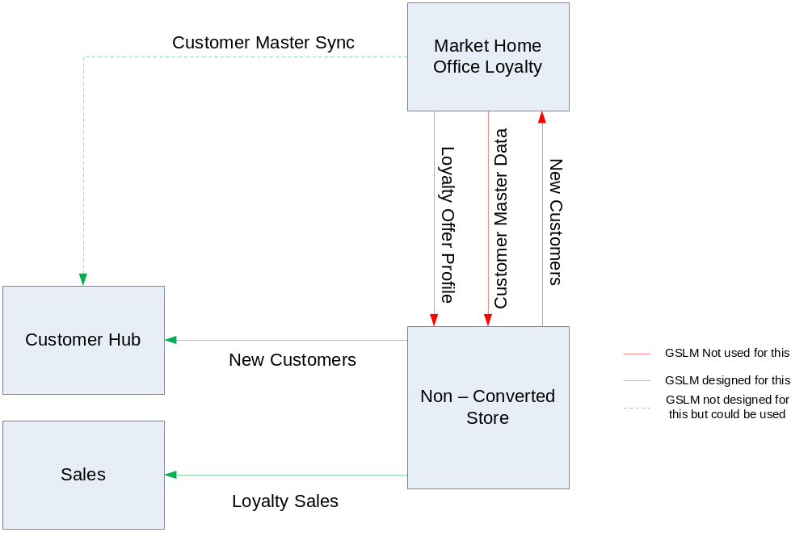
Assumptions:
- The GSLM will not provide the ability to offer membership or loyalty services to a market, the intent is to capture customer profile data and provide a link for marketing and analysis between the Walmart’s global customer relationships and in market loyalty program.
- Market specific loyalty programs will define the customer offer for their registered base; the GSLM assumes that the functionality that drives the offer is resident in the non converted store systems.
- The GSLM will integrate the customer, contract, contract component and related entities to support this scope.
- No payment or Personal information requiring PCI or PII encryption will be stored for contacts created through loyalty program conversion.
- The security requirements for International Market to Home Office data transmission as well as market specific regulations must be addressed as part of the physical integration with an international data source.
- The GSLM will provide a stub out of privacy and consumer preferences that support basic opt in and contact preferences, the specific attributes for each market’s customer base would be defined as part of the physical implementation.

The following section describes the GSLM entities and their attributes which have been modeled as part of the Customer scope:
Entity Name | Description
Customer | This entity represents a member in the system. This could be an individual or an organization.
Attribute | Type | Description
wm_customer_id | Number | The global identifier of the Customer
customer_relationship_id | CustomerType | Defines the customer type Organization or individual / person
preferred_language_type | Code | Identifies the preferred member communication language
contact_active_ind | Indicator | Indentifies if the contact is active
last_update_date | Date | When a record is added or updated, this field is updated with the date and time. On subsequent updates, WCC uses this information to ensure that the update request includes a matching date and time on this field; if it does not, the update fails.
Entity Name | Description
CustomerRelationship | This entity is a logical construct which defines the type of relationship associated with a particular Walmart customer id (organization or person).
Attribute | Type | Description
Customer_relationship_id | Number | Unique identifier of the customer relationship
customer_relationship_type | Code | Defines the type of relationship (Organization, Person)
Entity Name | Description
Organization | This entity represents a contact as an organization
Attribute | Type | Description
organization_id | CustomerRelationship | The unique organization id
contact_id | Contacts | Foreign Key to the contact
organization_name_id | OrganizationNames | Foreign Key to the organization name
organization_type | Code | type of organization
Entity Name | Description
OrgPersonBreakout | This entity defines the group of people in the person entity which are members of the organization.
Attribute | Type | Description
organization_id | Organizations | Foreign Key to the organization entity
person_id | Persons | Foreign Key to the person entity
org_role_type | Code | Defines the persons role in the organization
Entity Name | Description
Person | This entity represents a contact as a Person
Attribute | Type | Description
person_id | CustomerRelationship
birth_date | Date | date of birth
gender_type | Code | gender
name_type | Code | type of name
given_name_one | Text | first name
given_name_two | Text | middle name
last_name | Text | last name
Entity Name | Description
ContactMethod | This entity represents the various contact methods, email and phone
Attribute | Type | Description
contact_method_id | Number | The unique contact method id
reference_nbr | Text | contact method value, e.g. entire phone number or email address
contact_method_usage_type | Code | Identifies the contact method type
last_update_date | Date | When a record is added or updated, this field is updated with the date and time. On subsequent updates, WCC uses this information to ensure that the update request includes a matching date and time on this field; if it does not, the update fails.
Entity Name | Description
EmailAddress | This entity represents an email address
Attribute | Type | Description
email_address_id | Number | The unique email address id
email_address_type | Code | Identifies the type of email
email_address | Text | actual email
Entity Name | Description
PhoneNumber | This entity represents a phone number
Attribute | Type | Description
phone_nbr_id | Number | The unique phone number id
phone_nbr_type | Code | Identifies the type of phone number
phone_area_code | Number | Identifies the phone's area code
phone_exchange | Number | Identifies the phone's exchange
phone_nbr | Number | Identifies the phone number
Entity Name | Description
Address | This entity represents an address
Attribute | Type | Description
address_id | Number | The unique address id
address_usage_type | Code | Identifies the type of address
last_update_date | Date | When a record is added or updated, this field is updated with the date and time. On subsequent updates, WCC uses this information to ensure that the update request includes a matching date and time on this field; if it does not, the update fails.
address_line_one | Text | Identifies the Address Line 1
address_line_two | Text | Identifies the Address Line 2
address_line_three | Text | Identifies the Address Line 3
city | Text | Identifies the city
zip_postal_code | Text | Identifies the zip code
province_state_type | Code | Identifies the State/Province code
country_type | Code | Identifies the Country code
Entity Name | Description
BusinessRelationship | The entity defines the relationship between a customer and Walmart.
Attribute | Type |  | Description
business_relationship_id | Number |  | The unique contract id
native_key_id | NativeKeys |  | Foreign key to the Native Key entity, part of the composite key which defines a unique native key within a business division.
business_division_id | BusinessDivisions |  | Foreign key to the Business Divisions entity, part of the composite key which defines a unique native key within a business division.
last_update_date | Date |  | When a record is added or updated, this field is updated with the date and time. On subsequent updates, WCC uses this information to ensure that the update request includes a matching date and time on this field; if it does not, the update fails.
end_date | Date |  | The date that this row of data became invalid.
contract_lob_type | Code |  | 1 Walmart  18 Sam's Club  1000018 Mas Club
country_type | Code |  | country type for this contract, e.g. this is set to US for US Clubs and PR for Porte rico
Entity Name | Description
BusinessRelationship  Component | The membership structure maps into WCC contract component structure. E.g. currently, this contain the following components: Base, Plus, Tax-Exempt, and Cigarette Tax-Exempt.
Attribute | Type | Description
business_relationship_  component_id | Number | The unique contract component id
business_relationship_id | BusinessRelationships | Foreign Key to the owner contract id
base_ind | Indicator | Used to identify the base component of the contract. Every contract has at least one component, the base component.
last_update_date | Date | When a record is added or updated, this field is updated with the date and time. On subsequent updates, WCC uses this information to ensure that the update request includes a matching date and time on this field; if it does not, the update fails.
contract_status_type | Code | Identifies the status of the contract. For example: ″active″, ″pending″, lapse pending″, or ″cancelled″. These values are provided by the administrative source systems of the contract.
issue_date | Date | The date which the contract component was issued.
end_date | Date | The date that this row of data became invalid.
expiry_date | Date | The date that the type code is no longer valid.
product_type | Code | Identifies the type of product associated with the contract (or at some level within the product family). E.g. WMT Walmart Account, Plus Advantage etc.
Entity Name | Description
BusinessRelationshipRole | The entity specifies what contacts can do with the applied contract component
Attribute | Type | Description
business_relationship_  role_id | Number | The unique contract role id
business_relationship_id | BusinessRelationships | Foreign Key to the owner contact id
business_relationship_  component_id | BusinessRelationship  Components | Foreign Key to the contract component this role applies to
native_key_id | NativeKeys | Foreign key to the Native Key entity, part of the composite key which defines a unique native key within a business division.
business_division_id | BusinessDivisions | Foreign key to the Business Divisions entity, part of the composite key which defines a unique native key within a business division.
arrangement_type | Code | contract status
recorded_start_date | Date | The date which the party’s relationship to the contract became legally effective. This is commonly the date which the party signed the contract.
role_type | Code | Identifies the type of role that a contact may have on a contract.
start_date | Date | The date that this row of data became valid.
end_date | Date | The date that this row of data became invalid.
card_holder_nbr | Number | Identifies an individual on the base component, this is only used by Membership
role_desc | Text | role description, e.g. Household
Entity Name | Description
NativeKey | The entity is used to define the various unique keys that represent a customer relationship.
Attribute | Type | Description
native_key_id | Number | The native key is a system generated unique identifier for the business relationship which has been generated by a source system (e.g. SAM's membership number, walmart.com id, loyalty card number)
business_division_id | BusinessDivisions | Foreign key to the Business Divisions entity, part of the composite key which defines a unique native key within a business division.
admin_contract_id | Number | The actual text or number that is used in the administrative source system to identify a contract.
admin_field_name_type | Code | Identifies the field name that the native key refers to, for example, policy number, policy suffix, account number, branch, and others.
last_update_date | Date | When a record is added or updated, this field is updated with the date and time. On subsequent updates, WCC uses this information to ensure that the update request includes a matching date and time on this field; if it does not, the update fails.
contract_component_ind | Indicator | Describes which table the native key applies to. If the contract component indicator is ’Y’, the native key applies to the Contract Component. If the contract indicator is not ’Y’, the native key applies to the Contract. The contract ID is the value from the Contract Component (the contract component ID).
Entity Name | Description
PrivacyOption | This entity represents the various preference opt in options that customers can opt into, preferences are maintained at the business division level. (e.g. a customer can define separate contact preferences for Sam's vs. Walmart)
Attribute | Type | Description
privacy_option_id | Number | The unique privacy option id
business_division_id | BusinessDivisions | Foreign key to the Business Divisions entity
default_opt_in_ind | Indicator | default value for this opt-in
country_type | Code | Identifies the country for this opt-in
privacy_opt_cat_type | Code

